**JAVA LAB**

1. to print an integer given by user

import java.util.Scanner;

class A {

public static void main(String[] args)

{

Scanner sc = new Scanner(System.in);

System.out.println(" enter integer:- ");

int n = sc.nextInt();

System.out.println(" num is " + n);

}

}

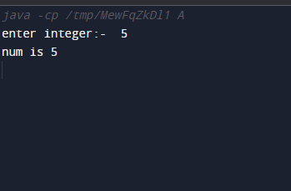

2. to check the number is even or odd

import java.util.Scanner;

class A {

public static void main(String[] args)

{

Scanner sc = new Scanner(System.in);

System.out.println(" enter integer:- ");

int n= sc.nextInt();

if(n%2==0)

System.out.println("the is " +n+ " is even");

else System.out.println( " the is " +n+ " is odd");

}

}

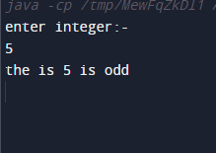

3. WAP to check weather a given character is vowel or consonant

import java.util.Scanner;

class A {

public static void main(String[] args)

{

Scanner sc = new Scanner(System.in);

System.out.println(" enter Char:- ");

char c = sc.next().charAt(0);

if(c == 'a'|| c == 'A'||c == 'e' || c == 'E'||c == 'i'||c == 'I'||c == 'o'|| c == 'O'|| c == 'u'|| c == 'U')

System.out.println("the is"+c+" is vowel");

else

System.out.println("tie is"+c+ " is consonant");

}

}

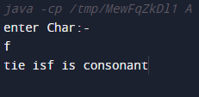

4. WAP to print sum all the number to any given integer number (range addition)

import java.util.Scanner;

class A {

public static void main(String[] args)

{

Scanner sc = new Scanner(System.in);

System.out.println(" enter range:- ");

int n=sc.nextInt();

float sum=0;

for(int i =1;i<=n;i++)

{

sum = sum+i;

}

System.out.println(sum);

}

}

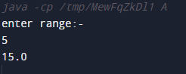

5. WAP to print A to Z using loop

import java.util.Scanner;

class A {

public static void main(String[] args)

{

Scanner sc = new Scanner(System.in);

{

for(char i='A'; i<='Z'; i++)

{

System.out.print(i);

}

}

}

}

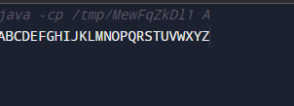

6. WAP to print greatest common divider (GCD) of 2 numbers (not running)

import java.util.Scanner;

class A {

public static void main(String[] args)

{

int gcd= 1;

int n1 = 30;

int n2 = 45;

for(int i=1;i<=n1 && i<=n2;i++)

{

if ( n1%i==0&&n2%i==0)

gcd = i;

{

System.out.println(" GCD OF " +n1+ " and " +n2+ " is " +gcd);

}

}

}

}

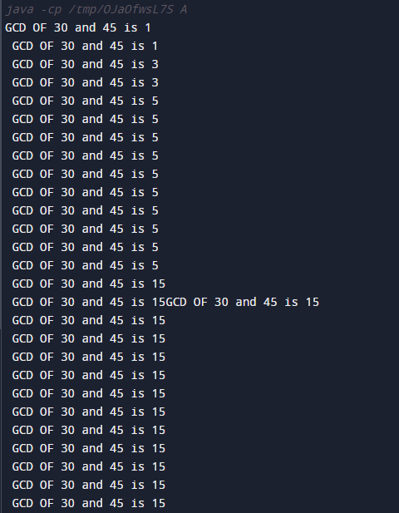

7. WAP to print a table of a given number

import java.util.Scanner;

class A

{

public static void main(String[] args)

{

Scanner sc=new Scanner(System.in);

System.out.println(" enter number :- ");

int n=sc.nextInt();

for(int i=1;i<=10;i++)

{

System.out.println(n+"*"+i+"="+n*i);

}

}

}

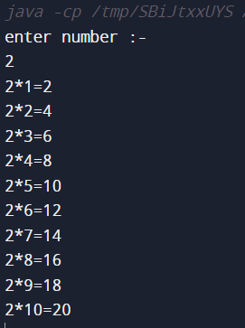

8. factorial of given numbers

import java.util.Scanner;

public class main

{

public static void main(String[] args)

{

Scanner sc = new Scanner (System.in);

System.out.println("Enter range: ");

int n = sc.nextInt();

int fact = 1;

for (int i=1;i<=n;i++)

{

fact=fact*i;

}

System.out.println(fact);

}

}

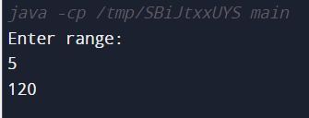

9. print of all even number upto 1 to 9

import java.util.Scanner;

public class A

{

public static void main (String[] args)

{

int n=9;

int i,d;

int sum=0;

for (i=2;i<=9;i+=2 )

{

d=sum+i;

System.out.print(" "+d+" ");

}

}

}

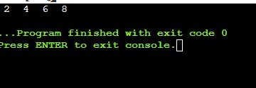

10.sum off two number

import java.util.Scanner;

class A

{

public static void main(String[] args)

{

int n,sum,i;

Scanner sc=new Scanner(System.in);

System.out.print("enter first number:- ");

n=sc.nextInt();

System.out.print("enter secund number:- ");

i=sc.nextInt();

// System.out.print("enter secund number:- ");

sum=n+i;

System.out.println(" sum = :- "+sum);

}

}

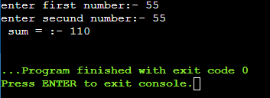

11.FIBONACCI SERIES

import java.util.Scanner;

class A

{

public static void main(String[] args)

{

int a=0,b=1,n,c;

Scanner sc=new Scanner(System.in);

System.out.print("Enter number:- ");

n=sc.nextInt();

System.out.print("The series is :- ");

for(int i=1;i<=n;i++)

{

c=a+b;

System.out.print(" "+c+" ");

a=b;

b=c;

}

}

}

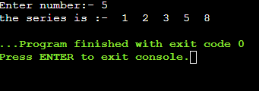

//12.* pattern

import java.util.Scanner;

class A

{

public static void main(String[] args)

{

System.out.println("pattern is:- ");

for(int i=1;i<=5;i++)

{

for(int j=1;j<=i;j++)

{

System.out.print("*");

}

System.out.println();

}

}

}

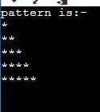

//13. Wrapper Example1

import java.util.Scanner;

public class WrapperExample1

{

public static void main(String args[]){

int a=20;

Integer i=Integer.valueOf(a);

Integer j=a;

System.out.println(a+" "+i+" "+j);

}

}



///14. WrapperExample2

import java.util.Scanner;

public class WrapperExample2

{

public static void main(String args[]){

//int a=20;

Integer a=new Integer(3);

int i=a.intValue();

int j=a;

System.out.println(a+" "+i+" "+j);

}

}

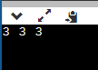

//15.creating a class and instance (Object)

import java.util.Scanner;

public class C

{

int x=5;

public static void main (String[] args) {

C Object =new C ();

System.out.print("the value assimble is :- "+Object.x);

}

}



//16.simple public class using instance/class variable

import java.util.Scanner;

public class A

{

int x=10;

public static void main (String[] args) {

A Object=new A();

System.out.print("the assin value is :- "+Object.x);

}

}



//17.Reverse of number

import java.util.Scanner;

public class A

{

public static void main (String[] args) {

Scanner r=new Scanner(System.in);

System.out.print("Enter any number:- ");

int num = r.nextInt();

int rev =0;

int rem;

while (num !=0)

{

rem=num%10;

num/=10;

rev=rev*10+rem;

}

System.out.print("The revrsal of number is:- "+rev);

}

}

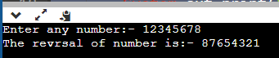

//18.print number of Object created in a program

import java.util.Scanner;

public class Swap

{

static int count;

Swap()

{

count++;

}

public static void main (String[] args) {

Swap s1=new Swap();

Swap s2=new Swap();

Swap s3=new Swap();

Swap s4=new Swap();

Swap s5=new Swap();

Swap s6=new Swap();

Swap s7=new Swap();

Swap s8=new Swap();

System.out.println(" Swap count is :- "+count);

}

}

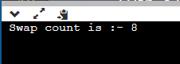

// 19.WrapperExample3 ATO BOXING

import java.util.Scanner;

public class WrapperExample2

{

public static void main(String args[]){

int i=20;

boolean a = true;

char c ='a';

byte b=1;

short s= 8;

long l=6;

float f=7.9F;

double d=8.0D;

Integer I=Integer.valueOf(20);

//int i=a.intValue();

Integer j=i;

System.out.println(a+" "+c+" "+b+" "+s+" "+i+" "+l+" "+f+" "+d+" "+j);

}

}

